**Render Texture**

[SWITCH TO SCRIPTING](http://docs.unity3d.com/540/Documentation/ScriptReference/RenderTexture.html)

**Render Textures** are special types of **Textures** that are created and updated at runtime. To use them, you first create a new Render Texture and designate one of your [Cameras](http://docs.unity3d.com/540/Documentation/Manual/class-Camera.html) to render into it. Then you can use the Render Texture in a **Material** just like a regular Texture. The [Water](http://docs.unity3d.com/540/Documentation/Manual/HOWTO-Water.html) prefabs in Unity Standard Assets are an example of real-world use of Render Textures for making real-time reflections and refractions.

**Render Textures** 是一类可以在运行时创建和更新的特殊的纹理。

。如果要使用它，首先创建一个新的Render Texture并为它指派一个相机来进行渲染。然后你就可以像使用普通纹理贴图那样在材质中使用Render Texture。在Unity标准资源库中的例子中水的预设是使用一个Render Texture实时的反射和折射。

**Properties**

**属性**

The Render Texture **Inspector** is different from most Inspectors, but very similar to the [Texture Inspector](http://docs.unity3d.com/540/Documentation/Manual/class-TextureImporter.html).

Render Texture的展示面板和大多数展示面板不同，但是非常像[Texture Inspector](http://docs.unity3d.com/540/Documentation/Manual/class-TextureImporter.html).

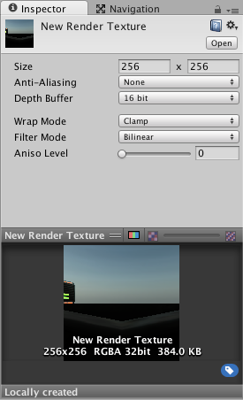The Render Texture Inspector is almost identical to the Texture Inspector

Render Texture的展示面板和Texture的展示面板几乎相同。

The Render Texture inspector displays the current contents of Render Texture in realtime and can be an invaluable debugging tool for effects that use render textures.

Render Texture展示面板实时展示了当前Render Texture的内容并且它是使用了render texture特效的宝贵的调试工具。

| ***Property:*** | ***Function:*** |
| --- | --- |
| **Size**  **大小** | The size of the Render Texture in pixels. Observe that only power-of-two values sizes can be chosen.  Render Texture的大小（像素为单位）。只可以选择2的幂值。 |
| **Anti-Aliasing**  **抗锯齿** | The amount of anti-aliasing to be applied. None, two, four or eight samples.  应用的抗锯齿数量。无，2,4或者8个采样 |
| **Depth Buffer**  **深度缓冲区** | The type of the depth buffer. None, 16 bit or 24 bit.  深度缓冲区的类型。无，16位，24位 |
| **Wrap** **Mode** | Selects how the Texture behaves when tiled:  选择图片如何平铺 |
| **Repeat**  **循环** | The Texture repeats (tiles) itself  图片的自循环 |
| **Clamp**  **限制** | The Texture’s edges get stretched  图片被拉伸的边 |
| **Filter Mode**  **过滤模式** | Selects how the Texture is filtered when it gets stretched by 3D transformations:  选择当该纹理由于3D变换被拉伸时它将如何过滤 |
| **No Filtering**  **无过滤** | The Texture becomes blocky up close  纹理将变得块状化 |
| **Bilinear**  **双线性插值** | The Texture becomes blurry up close  纹理将变得模糊 |
| **Trilinear**  **三线性插值** | Like Bilinear, but the Texture also blurs between the different mip levels  类似双线性插值，但纹理还会在不同的mip水平之间进行模糊； |
| **Aniso Level**  **抗锯齿等级** | Increases Texture quality when viewing the texture at a steep angle. Good for floor and ground textures  当处在一个比较陡的角度看纹理时可以提升贴图的品质。对于地板和地面贴图来说很好。 |

**Example**

**例子**

A very quick way to make a live arena-camera in your game:

在你游戏中快速创建一个现场舞台式的摄像机的一种方式：

1. Create a new Render Texture asset using **Assets->Create->Render Texture**.
2. 创建一个新的Render Texture资源，使用**Assets->Create->Render Texture**菜单。
3. Create a new Camera using **GameObject > Create General > Camera.**

创建一个新的摄像机，使用**GameObject > Create General > Camera**菜单

1. Assign the Render Texture to the **Target Texture** of the new Camera.

指定Render Texutre到新摄像机里的**Target Texture选项。**

1. Create a wide, tall and thin box

创建一个宽，高，瘦的盒子。

1. Drag the Render Texture onto it to create a Material that uses the render texture.

拖拽Render Texure到一个新的材质里，使用Render Texture。

1. Enter Play Mode, and observe that the box’s texture is updated in real-time based on the new Camera’s output.

进入播放模式，并且观察盒子的贴图是基于新摄像机的输出而实时更新的。

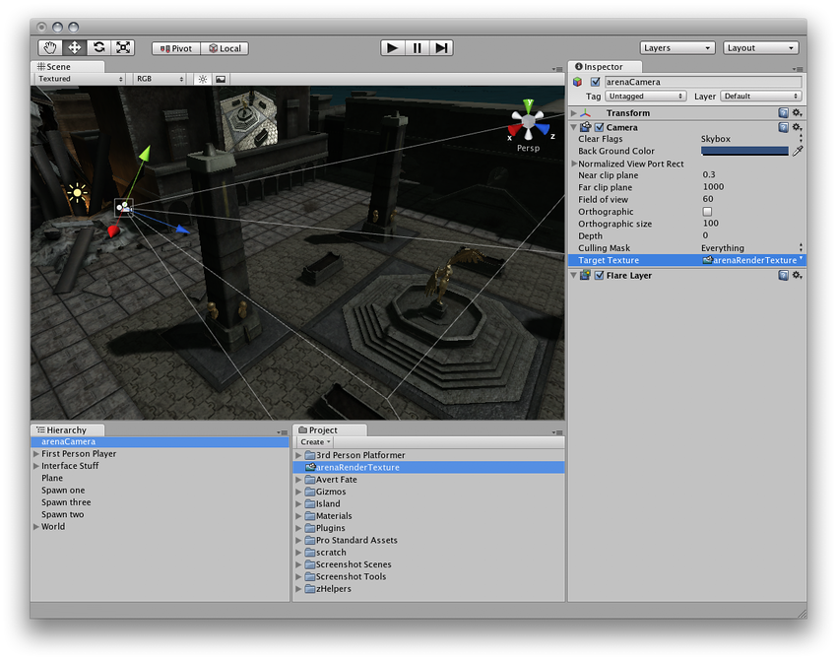Render Textures are set up as demonstrated above

渲染纹理的设置如上所述